Llangwm Village, Pembrokeshire

Environment (Wales) Act 2016 Part 1 – Section 6

The Biodiversity and Resilience of Ecosystems Duty

Report of Llangwm Community Council, April 2025.

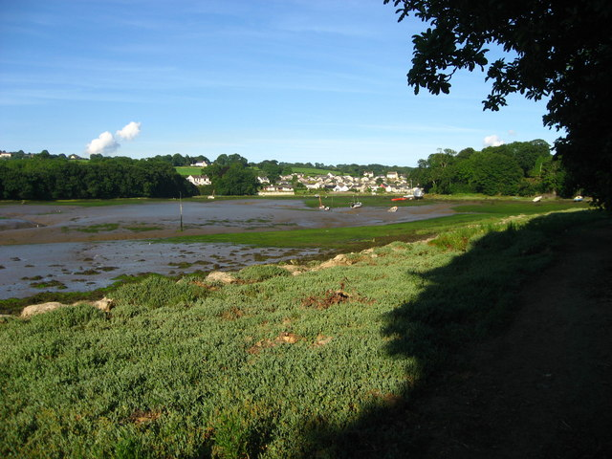

Llangwm Village is situated on the Daugleddau Estuary and consists of approximately 450 properties contained in the main village and surrounding areas of Llangwm Ferry, Black Tar and Deerland.

The area around the estuary is designated as a Special Area of Conservation (SAC) and a Special Site of Scientific Interest (SSSI), and is within the Pembrokeshire Coast National Park Boundary.

The village itself is designated a Service Village in the Pembrokeshire County Council Local Development Plan, and part of the village centre is a Conservation Area. LLANGWM.pdf

Outside the village in the Community Council area is the is the hamlet of Deerland and several farms.

Llangwm was once a thriving fishing village thriving with a history in the oyster and herring industries. The village is surrounded by farmland which is mostly grassland and not subject to intensive farming.

Llangwm Community Council has joint custodianship of several areas of Common Land, (the village green and land at Black Tar), and also ownerships of the village recreation field, Pill Parks.

Under section 6 of the Environment Wales Act, Llangwm Community Council has a requirement to maintain and enhance biodiversity in the exercise of its functions in relation to Wales, and in so doing promote the resilience of ecosystems, so far as consistent with the proper exercise of those functions.
The Main priorities for the Council are to maintain and enhance biodiversity follows the Nature Recovery Action Plan for Wales (NRAP) guidance. In producing a plan that supports the guidance the key priorities for the Council are to:
- Ensure matters relating to Biodiversity are included in the decision-making process.
- Raise awareness of the importance of biodiversity
- Be aware of any habitats or species that need protection and safeguarding
- Being alert to opportunities to restore or create particular habitats.
- Promote sustainability and biodiversity though our decisions whenever possible;
- Ensure biodiversity is considered in planning consultation responses.

Recent Actions

  - Tree Planting scheme in conjunction with local residents and pupils at Cleddau Reach School.
  - Removal of dead trees at Pill Parks and commission a Tree Report to ensure public safety and replacement where necessary, budgeting via the precept.
  - Request to Pembrokeshire Count Council highways not to cut a section of the village green to ensure native flowers and wildlife can flourish.
  - Supporting the inclusion of a “wild nature walks” in a major outline planning permission in the village.

A larger forward-looking plan is the development of a long-term project to bring green energy to the village, thus ensuring cheaper electricity for residents. A scoping exercise is being commissioned via PLANED and an updated report will be included in the next report.

LLANGWM COMMUNITY COUNCIL
…. APRIL 2025

